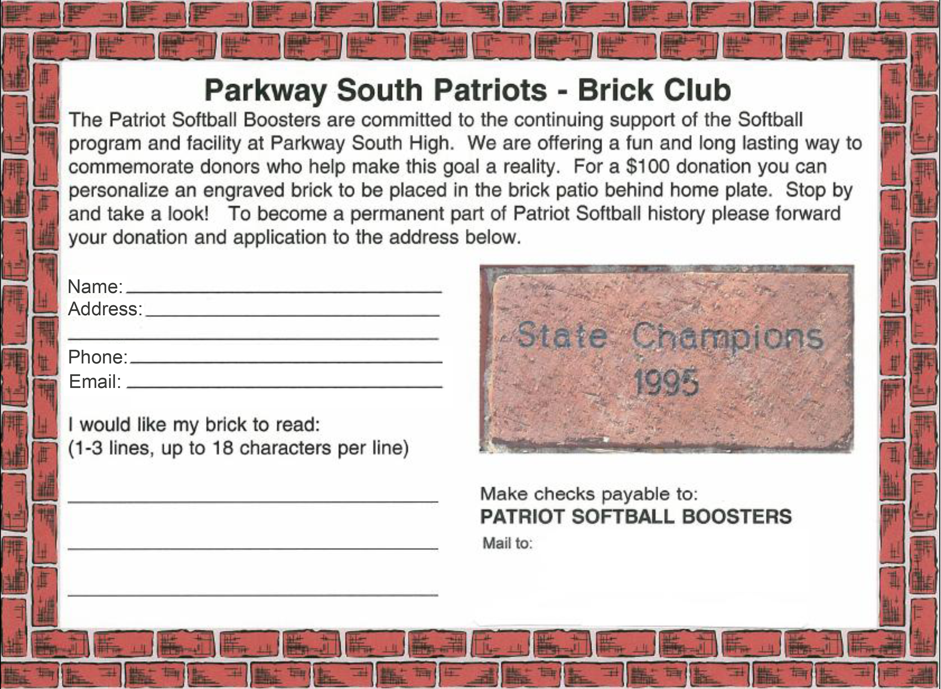

Lisa Kehlenbrink

384 Carr Manor Ct.

Ballwin, MO 63021